

**PROJECT REPORT**

**OM Project:  
“Optimizing Facility Layout of Reliance Mart ”**

**Group Number: 10**

**Group Members:**

|  |  |
| --- | --- |
| Name | ROLL NO. |
| ABHISHEK JOSHI | MBA25051 |
| SHASHANK KURNAL | MBA25226 |
| ANISH DEY | MBA25058 |
| ROHIT GHOSH | MBA25084 |
| SHREYA YADAV | MBA25090 |
| YOGANSHI | MBA25096 |
| NAMAN SRIVASTAV | MBATM25014 |

**ABSTRACT**

This project explains the effort to optimize the Facility Layout of Reliance Mart in Paonta Sahib, aiming to enhance operational efficiency and the overall customer experience significantly. The existing layout was facing several operational challenges, which include congested goods, placement of billing counters leading to long queues, and delays in stock replenishment due to the unfavourable location of the Storage section. The primary objectives were to improve customer flow, reduce congestion, enhance accessibility to high-demand sections, and optimize stock movement. A comparative analysis using the Activity Relationship Chart (Muther's Grid/ABC chart) informed the proposed improvements, which included widening of goods area, relocating the Household Section closer to the entrance, and shifting the Storage Section adjacent to Groceries for faster replenishment.

**EXECUTIVE SUMMARY**

This project focused on optimizing the facility layout of Reliance Mart in Paonta Sahib to enhance operational efficiency and customer experience. The existing facility, a multi-departmental retail store, presented critical challenges, including congested aisles, especially during peak hours, inefficient placement of billing counters leading to long queues, and limited accessibility to high-demand sections. Furthermore, the Storage section's location caused delays in stock replenishment.

The key objectives were to improve customer flow, reduce congestion, and streamline stock movement. Based on an analysis using the Activity Relationship Chart (Muther's Grid) , the proposed solutions include widening aisles, relocating the Household Section closer to the entrance for better visibility, and strategically redistributing billing counters across three key zones. Crucially, the Storage Section will be moved adjacent to the Groceries and Household sections to ensure faster replenishment.

Quantitatively, the optimization yielded significant results, reducing the total aggregated layout deviation from **150 units** in the existing plan to **95 units** in the proposed plan. This represents a substantial **36.67% improvement** in layout efficiency. The new layout is projected to significantly improve customer satisfaction and operational performance

**Optimizing the Facility Layout of Reliance Mart, Paonta Sahib**

**1. Introduction**

Facility layout plays a critical role in determining the efficiency of operations and the quality of customer experience in retail environments. An effective layout ensures smooth customer flow, reduces congestion, improves accessibility to high-demand sections, and facilitates efficient internal movement of goods. In organized retail formats such as supermarkets and hypermarkets, poor layout decisions can directly translate into longer queues, stock-outs, customer dissatisfaction, and reduced sales.

This project focuses on the facility layout optimization of Reliance Mart, Paonta Sahib. Despite being a popular retail destination with substantial daily footfall, the store’s existing layout exhibited multiple operational inefficiencies. These issues necessitated a systematic study and redesign of the layout using established facility planning tools.

**2. Description of the Existing Facility**

**Facility Name:** Reliance Mart, Paonta Sahib  
**Location:** Near the main market area, Paonta Sahib  
**Type:** Multi-departmental retail store

**2.1 Store Profile**

Reliance Mart serves customers from Paonta Sahib and nearby regions by offering groceries, packaged food, household items, electronics, and other daily essentials under one roof. The store experiences an average daily footfall of approximately 500–700 customers.

**2.2 Major Departments**

* Groceries and packaged food
* Household items
* Electronics
* Billing counters
* Storage/Warehouse section

**2.3 Key Operational Issues Identified**

* Congested aisles, especially in grocery and household sections during peak hours
* Inefficient placement of billing counters near the entrance leading to long queues
* Limited visibility and accessibility of the household section
* Storage section located far from sales areas, causing delays in stock replenishment

**3. Objectives of the Study**

The primary objectives of the project were:

* To optimize the facility layout to improve customer flow and reduce congestion
* To enhance accessibility to high-demand sections
* To improve operational efficiency by reducing stock replenishment time
* To minimize deviations in activity relationships among departments
* To propose a practical and implementable layout improvement

**4. Methodology**

The study followed a structured facility layout planning approach:

1. Site visit and observation of customer movement and operational flow
2. Identification of bottlenecks and inefficiencies in the existing layout
3. Development of an Activity Relationship Chart using Muther’s Grid
4. Evaluation of the existing layout using deviation analysis
5. Design of a proposed layout based on relationship priorities
6. Comparison of existing and proposed layouts using quantitative measure

**5. Activity Relationship Chart (Muther’s Grid)**

The Activity Relationship Chart was used to assess the closeness requirements between departments based on operational dependency and customer flow.

**5.1 Relationship Symbols Used**

* **A** – Absolutely Necessary
* **E** – Especially Important
* **I** – Important
* **O** – Ordinary
* **U** – Unimportant
* **X** – Undesirable

|  |  |  |  |  |  |  |
| --- | --- | --- | --- | --- | --- | --- |
| DEPARTMENTS | GROCERIES | CLOTHING | ELECTRONICS | HOUSEHOLD | BILLING | STORAGE |
| GROCERIES | A | I | O | E | A | E |
| CLOTHING |  | A | E | O | E | O |
| ELECTRONICS |  |  | A | E | E | O |
| HOUSEHOLD |  |  |  | A | E | I |
| BILLING |  |  |  |  | A | E |
| STORAGE |  |  |  |  |  | A |

**5.2 Existing Activity Relationship Analysis**

The existing layout showed several mismatches between required and actual proximity, particularly between:

* Storage and Groceries
* Household section and entrance
* Billing counters and high-demand areas

These mismatches contributed significantly to higher layout deviation

**6. Existing Layout Description**

**6.1 Layout Characteristics**

* Groceries located near the entrance
* Household section positioned at the back of the store
* Electronics section located at the far end
* Billing counters unevenly distributed, with concentration near the entrance
* Storage section located at the rear, requiring long travel distances for restocking



**6.2 Limitations of the Existing Layout**

* Narrow aisles causing congestion
* Increased customer waiting time at billing counters
* Inefficient internal material handling
* Poor visibility of certain departments

**7. Proposed Improvements**

Based on the Activity Relationship Chart and on-site observations, the following improvements were proposed:

**7.1 Reorganization of Aisles**

* Widening aisles in grocery and household sections to reduce bottlenecks

**7.2 Relocation of Household Section**

* Moving the household section closer to the entrance to improve visibility and accessibility

**7.3 Redesign of Billing Counters**

* Redistribution of billing counters across three strategic zones to reduce queue buildup

**7.4 Optimization of Storage Placement**

* Relocating the storage section adjacent to groceries and household sections for faster replenishment

**8. Proposed (Ideal) Layout Description**

|  |  |  |  |  |  |  |
| --- | --- | --- | --- | --- | --- | --- |
| DEPARTMENTS | GROCERIES | CLOTHING | ELECTRONICS | HOUSEHOLD | BILLING | STORAGE |
| GROCERIES | A | E | E | E | A | A |
| CLOTHING |  | A | E | E | E | O |
| ELECTRONICS |  |  | A | E | A | O |
| HOUSEHOLD |  |  |  | A | E | E |
| BILLING |  |  |  |  | A | E |
| STORAGE |  |  |  |  |  | A |

**8.1 Key Features of the Proposed Layout**

* Groceries positioned along the right-hand side near the entrance
* Household section centrally located for balanced accessibility
* Billing counters placed near groceries, electronics, and exit points
* Storage section positioned adjacent to high-demand sections

The proposed layout aligns departmental placement with their closeness requirements, improving both customer movement and internal logistics.

**9. Layout Evaluation and Deviation Analysis**

**9.1 Aggregated Layout Deviations**

* **Existing Layout Deviation:** 150 units
* **Proposed Layout Deviation:** 95 units

**9.2 Improvement Calculation**

Improvement Percentage = ((150 − 95) / 150) × 100 = **36.67%**

This significant reduction demonstrates the effectiveness of the proposed layout in minimizing unnecessary movement and improving functional relationships.

**10. Results and Discussion**

The proposed facility layout offers the following benefits:

* Reduced congestion in high-traffic areas
* Improved customer flow and shopping experience
* Faster stock replenishment and reduced internal handling time
* Better utilization of available floor space
* Reduced customer waiting time at billing counters

Overall, the optimization enhances both operational efficiency and customer satisfaction.

**11. Managerial Implications**

* Retail managers can use systematic layout planning tools to identify inefficiencies
* Data-driven layout decisions can significantly improve customer experience
* Improved layout reduces operational costs related to handling and restocking
* The model can be replicated in similar retail outlets with minor customization

**12. Limitations of the Study**

* The study focuses on a single retail outlet
* Demand variability and seasonal effects were not explicitly modelled
* Cost-benefit analysis of implementation was not conducted

**13. Real-time Photos**

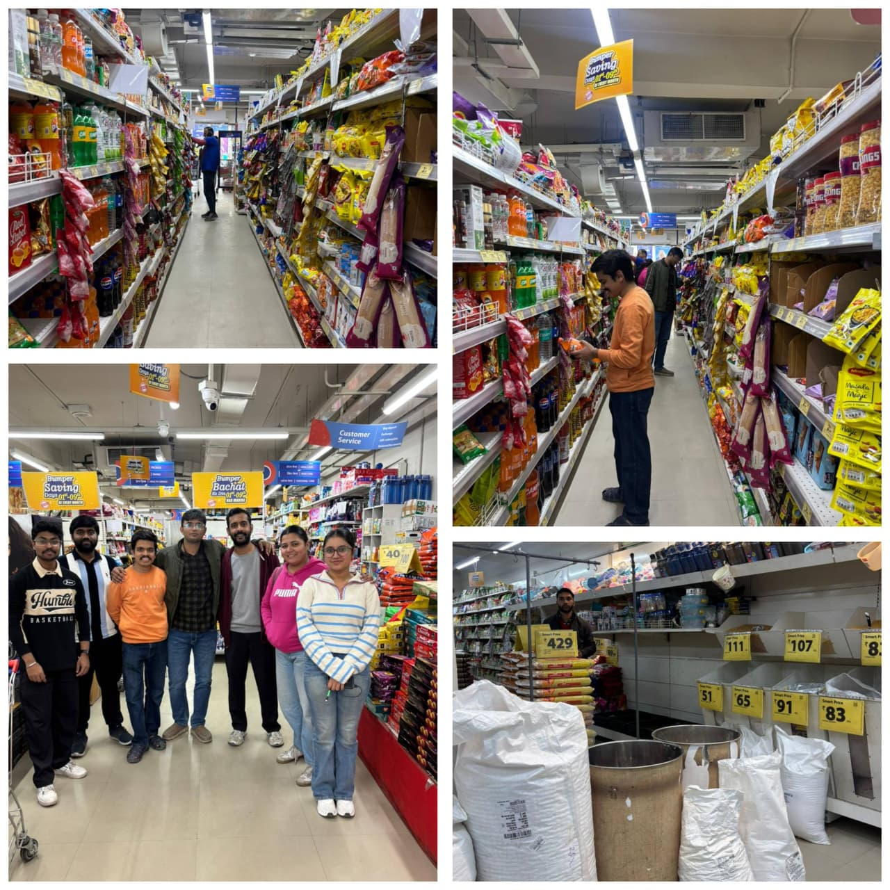

**14. Conclusion**

The facility layout optimization of Reliance Mart, Paonta Sahib demonstrates that systematic application of facility planning principles can lead to substantial operational improvements. By aligning departmental placements with activity relationships, the proposed layout achieved a **36.67%** improvement in layout efficiency. The optimized design is expected to enhance customer satisfaction, reduce congestion, and improve stock replenishment speed. The study reinforces the importance of scientific layout planning in modern retail operations.